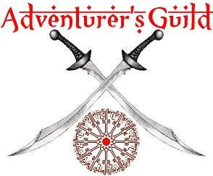
Kishar Player Character (v11.5)

Character Name |  | Player Name
Lineage |  | Progression | 3 (base) + 0 Events + 0 Bonus = 3
Class |  | Unspent
Base HP |  | Kismet | 0
Bonus HP | 0 | Standing
Total HP |  | Background(s)
Language(s) | The Jeweled Tongue
Notes
Rituals | - Choose two rituals!  - Check the Rituals section of the rulebook for more information.
Other Notes | Note Bonus HP items and Focus items here.

Lineage Abilities
Name | Effect

Universal (remove if none)
Name | Effect

Crafting (remove if none)
Name | Effect

Class Power Tree 1 (replace with actual name)
Name | Effect

Class Power Tree 2 (replace with actual name)
Name | Effect

Class Power Tree 3 (replace with actual name)
Name | Effect

